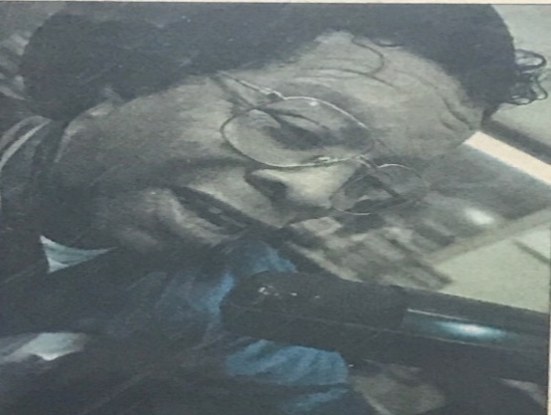
Willie J. Washington Memorial Scholarship
williejwashingtonmemorialscholarship@gmail.com

Willie Washington was well known around his community, Pickens County area, along with all of West Alabama. He was very passionate about helping others and serving his community. He and his wife Bernice, started a restaurant in Aliceville, Al called “Aliceville Religious Center.” Here he allowed others to come and host many programs, events, and church services. His doors were always open to those in need. Willie was also known for being “The Mouth of The South!” on WRAG 590AM. He was a Gospel Promoter & DJ for over 50 years serving East Mississippi & West Alabama. He has promoted businesses in Pickens, Greene, and Sumter Counties. Although Willie was a native of Aliceville, Al, He didn’t limit his helping hand to just one city. He never allowed what others may thought of as a disability, to hinder him from achieving things in life. His faith in God was always at its highest and his favorite saying was “If God Can’t Fix It, It’s Not Broke!” Even up until his last days of living, Willie was a fighter. He encouraged his friends and family to challenge themselves and always achieve what others may say you can’t. Willie always showed love and gave people a chance. This scholarship is to continue his legacy.
SirGENTZ INC seeks to promote minority male achievement and increase admission and graduation of minority males in higher education. SirGENTZ INC. also seeks to increase the number of minority males in careers in science, technology, engineering and mathematics. SirGENTZ INC wants to increase the exposure of young minority males to diverse ways of life through various programs, activities, and events. They also seek to enhance society with a lineage of minority males who exhibit talent, gentleman poise, leadership and sophisticated qualities. SirGENTZ INC seeks to uplift the lineage of minority males through cultivation of the mindset from the negative stereotype that exist to a higher standard. SirGENTZ INC. seeks to assist in creating a society where chivalry is relevant and young minority men are becoming strong kingdom men and residing off the streets and out of prison.
SirGENTZ INC is teaming up with the Willie J. Washington Memorial Scholarship. For more information on this great organization you may visit their website at www.sirgentzinc.weebly.com
Mission/Purpose The mission & purpose of this scholarship is to help young men/women be a step closer to accomplishing their dreams and education. With this scholarship we hope to assist you to being that much closer to making a difference in not only your life, but your community as well. This scholarship seeks to promote young entrepreneurs, journalists, commentators, etc. We seek to promote future businessmen and women and increase awareness to the greatness that lies within small communities.

Requirements
- High School Seniors
- College Undergraduate
- Must be a graduate of a West Alabama School listed: Pickens, Greene, Sumter County
- Must be attending an institution of higher learning in hopes to obtain a degree in the following: Communications, Telecommunications & Film, Journalism, Advertising, or Business.
- Minimum GPA-2.5 Cumulative
- Transcript (Unofficial or Official Accepted)
- Letter of recommendation

Rules
- Entire application must be completed and received by the deadline:
APRIL 13th, 2018 7PM.
- If mailed must be postmarked by April 13th, 2018.
- In order to be considered, must be present for an interview with scholarship committee which will be held on Saturday April 21st, 2018.

Willie J. Washington Memorial Scholarship
williejwashingtonmemorialscholarship@gmail.com

Application

Name: ________________________________________________________________
Last First M.I.

Permanent Residence: ___________________________________________________

Mailing Address: _____________________________________________________

Email Address: ______________________________

Phone: ____________________________________________
Home Cell

Date of Birth: _____________

Ethnicity/Race: ___________________________

Current GPA: ___________

Intended Major: _______________________

High School Attended/Attending:____________________________ Graduated Year:_____

Willie J. Washington Memorial Scholarship
williejwashingtonmemorialscholarship@gmail.com

Statement of Commitment
If chosen for this scholarship, I agree to take full advantage of this opportunity and not allow the award to be mishandled/misused. I also understand that my signature and submission of this application authorizes the scholarship committee of Willie J. Washington Memorial Scholarship, to obtain verification of information provided. All information provided is true to the best of my knowledge.

Signature of Applicant: ________________________________ Date: __________________

